**MicroChip ChipKit Max 32 Development System**

The chipKIT Max32 is a microcontroller board that is easy-to-use platform for developing advanced applications. It uses [chipKIT development environment](https://chipkit.net/wiki/index.php?title=ChipKIT_core" \t "_blank" \o "chipKIT-core™) and Arduino IDE for compatibility with existing code examples, tutorials and resources. Pin-compatible with many Arduino shields that can operate at 3.3V.   
  
 The PICkit 3 is a debugger controlled by the MPLAB IDE software. It is used along with the Microchip PIC microcontroller and Digital Signal Controller that are based on In Circuit Serial Programming (ICSP). Besides that, the PICkit 3 is also used to be a simple IDE for software developer with powerful compiler.  
  
Programs needed for this lab are MPLAB X IDE, XC32 C compiler.

Hardwar needed are Board with a Push Button and at least 2 LEDs.

**Part 1: Set Up**

In this section, we are going to install and set up the MPLAB X and MAXC32 and connect PICKit3 and Max32 bored to each other and to the computer.

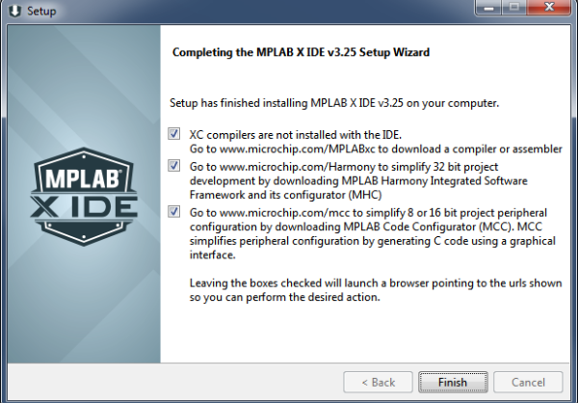

After installing the required software. We started by connecting the PICKit3 to the computer and to the Max32 board. Then, we connected the board with the button and LED to the Max32 ChipKit. Then we changed the source file a little bit by assigned pins to the button is set as an input and the pins assigned to the LEDs are set as OUTPUT pins

The program monitors the input switch and will change all the LEDs when the switch is pushed.  
  
**Part 2: Basic Debug**

In this section, we are going to attempt to build a program that controls LED on the board. We are going to do that by using BlinkWithButton in MPLab X ide.

* Circuit is as follows.

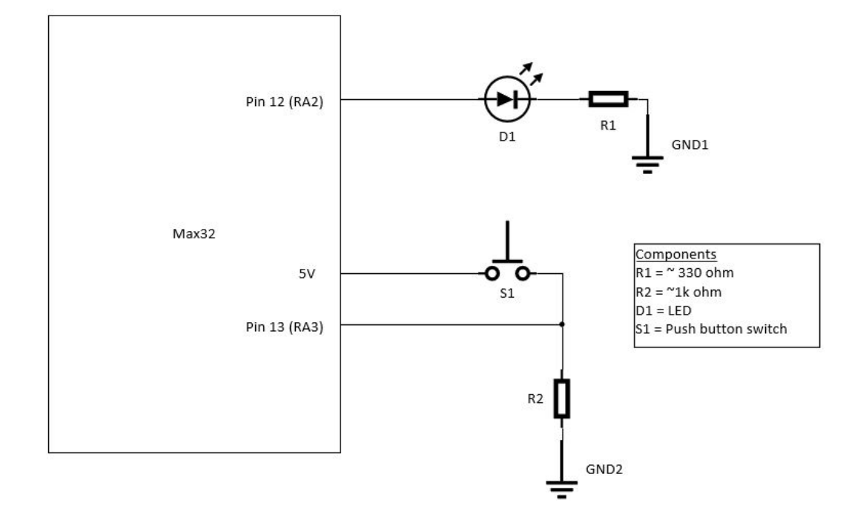

As we can see, we used single push button with a pull down resistor and single LED with a current limiting resistor.

* Build the Circuit

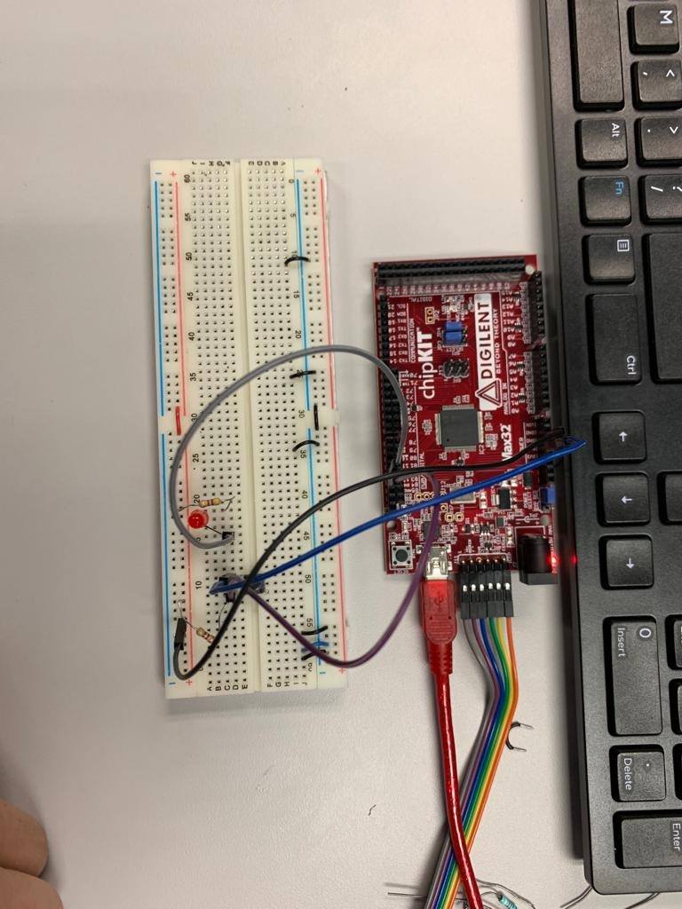

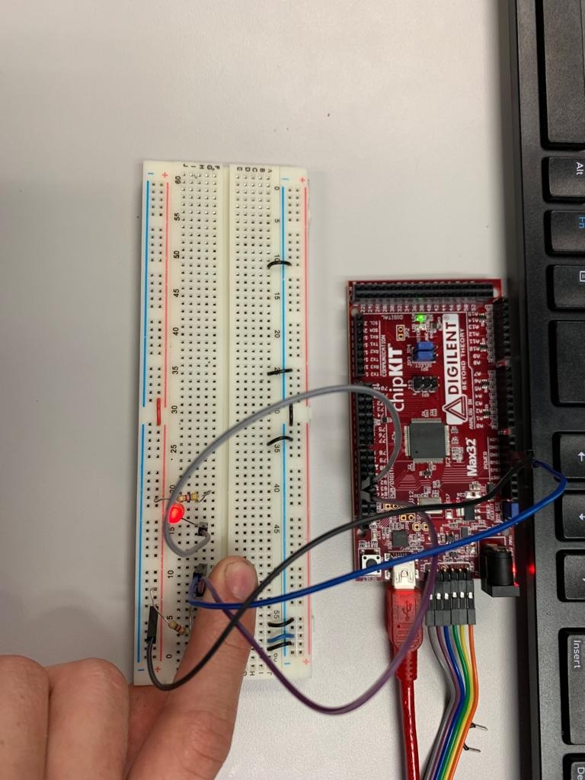

* The program works perfectly.

**Debug Breakpoints**In this part, we used the debugger to make oversee the program and to understand the behavior and to identify problems if any. We set breakpoint of which lines we want to see the program stop on and tell us what is going on with that line. We can set as many as breakpoints as we want.

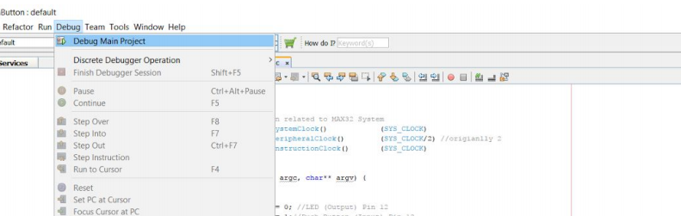

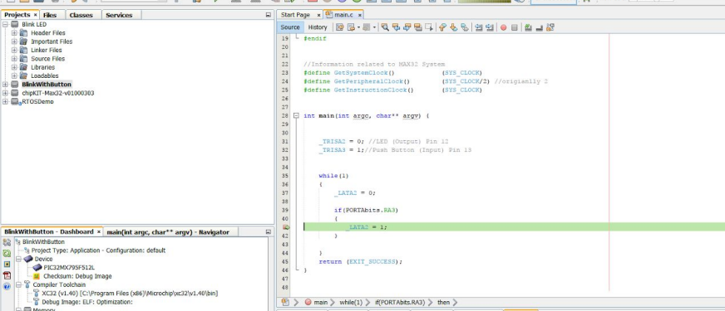

**Debug Watch Variable**

In this part, we are going to examine another debugging tool in program that using watches to observe registers and variables in our program.

* The following pictures is what I got when Debugging.

Below is values and circuit working with debugger from this part.

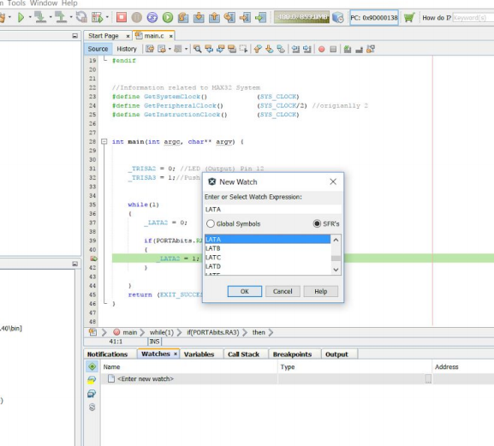

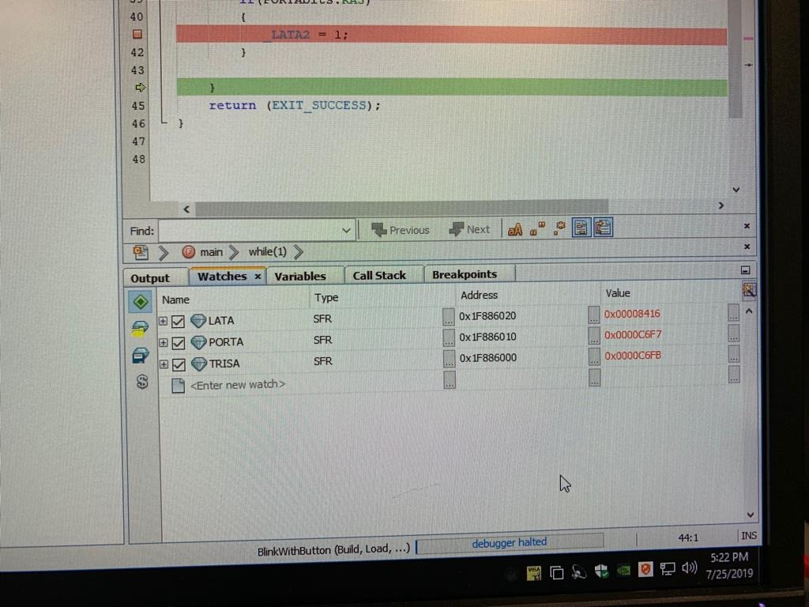

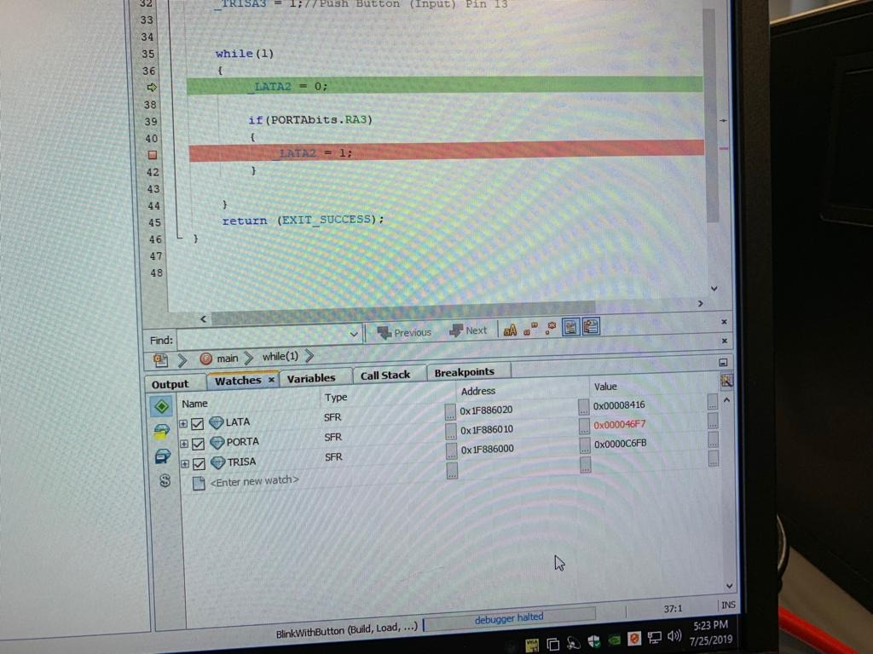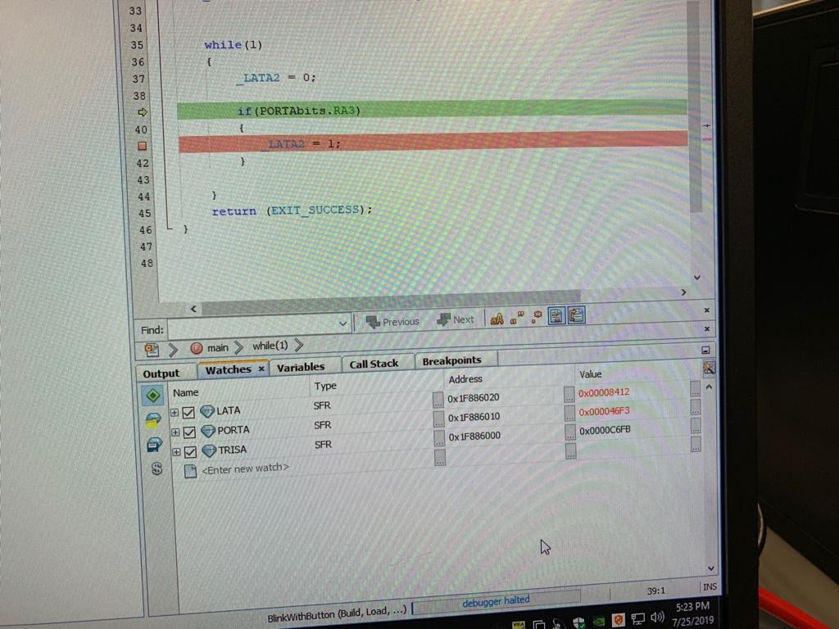

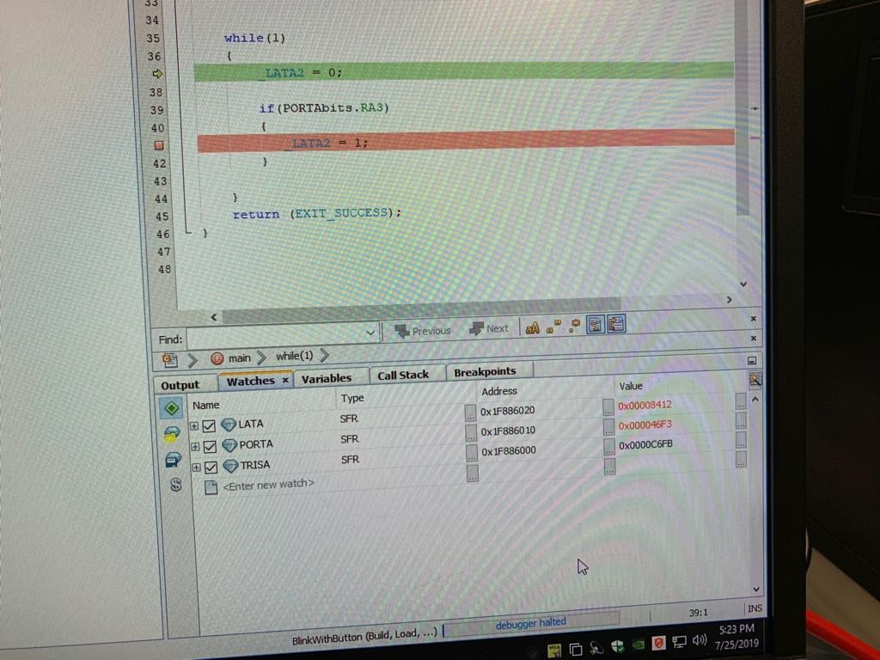

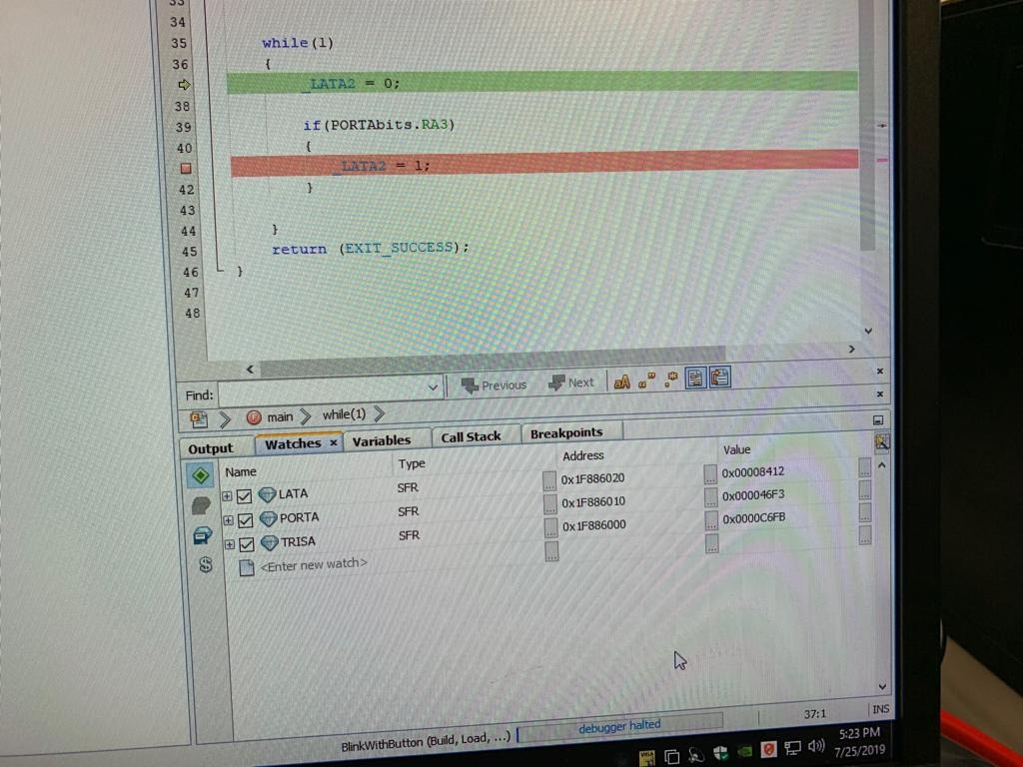

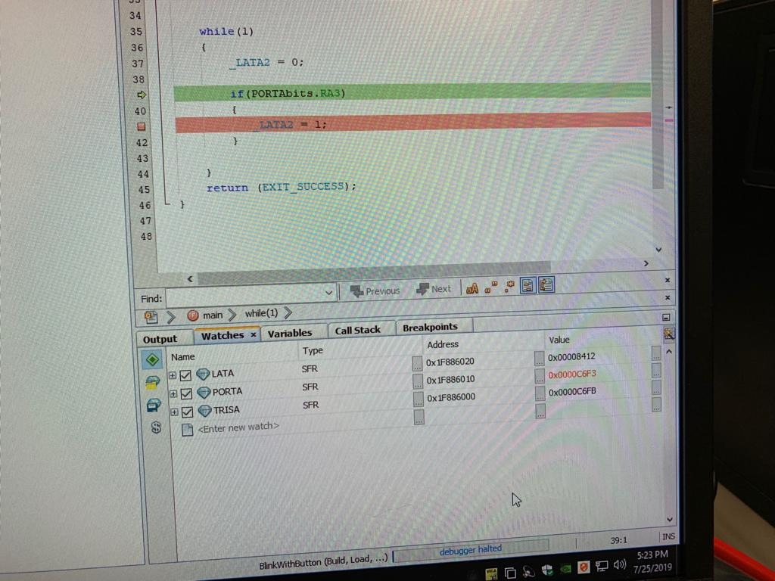



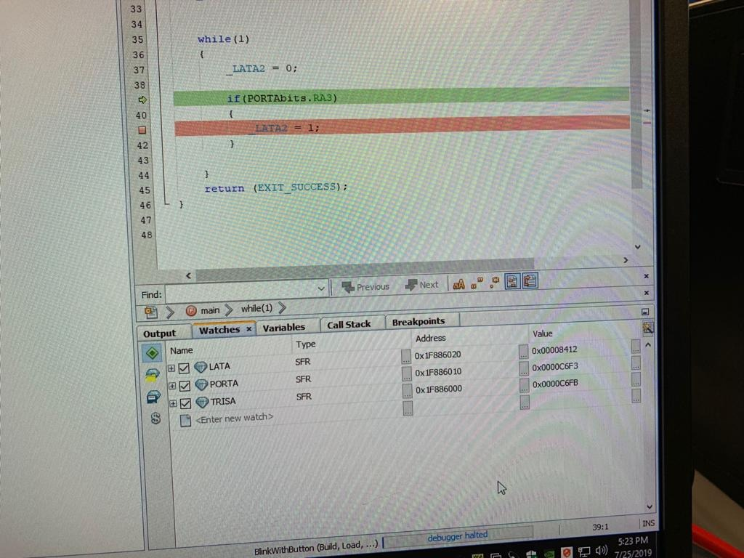

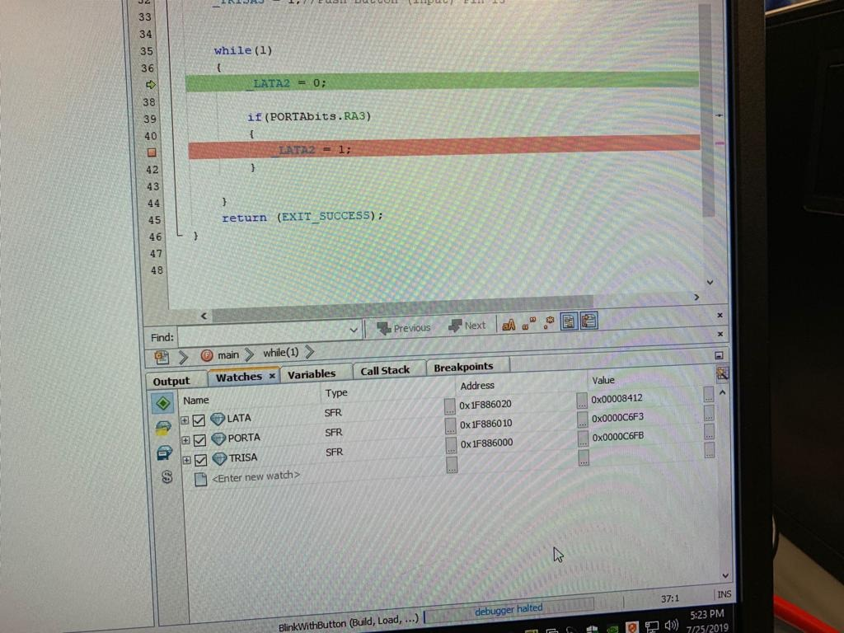

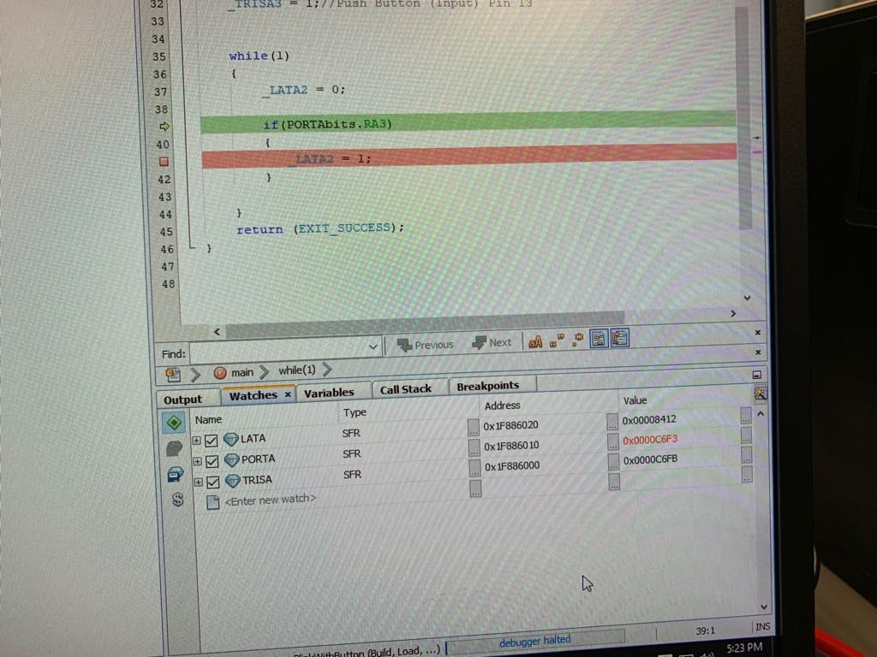

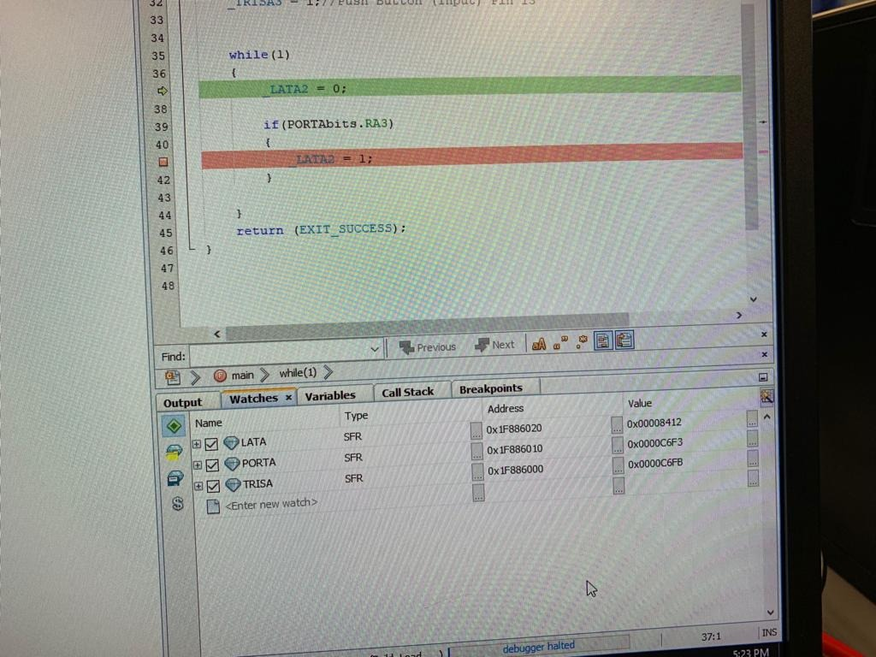

**Excel Values (Recorded):**

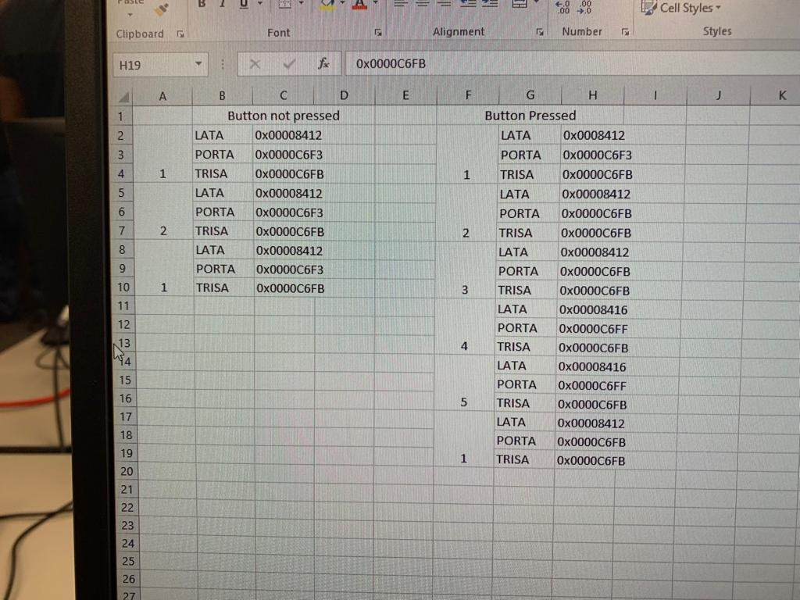

* The values recorded match with expected values.

**Part 3 Reload Arduino Bootloader**

For this part, we reprogrammed the ChipKIT-Max32-v010000303.hex into the PIC using IPE and the PICKit3.

**Conclusion**

Microchip PICkit3 is a very competent microcontroller with many strong features. Microchip PICkit3 has asserted its place and how important it is in the microcontroller industry by offering a excellent embedded design system along with comprehensive and profound guidance. The most exciting idea gained from this workshop is to be prepared to function in the easy and memory stage. This is a really great lab to explore, we introduced to a very powerful device that is used a lot in the industry. I feel like I am able to use it in my resume as software I am able to work on.